**Yuriy Tumakha**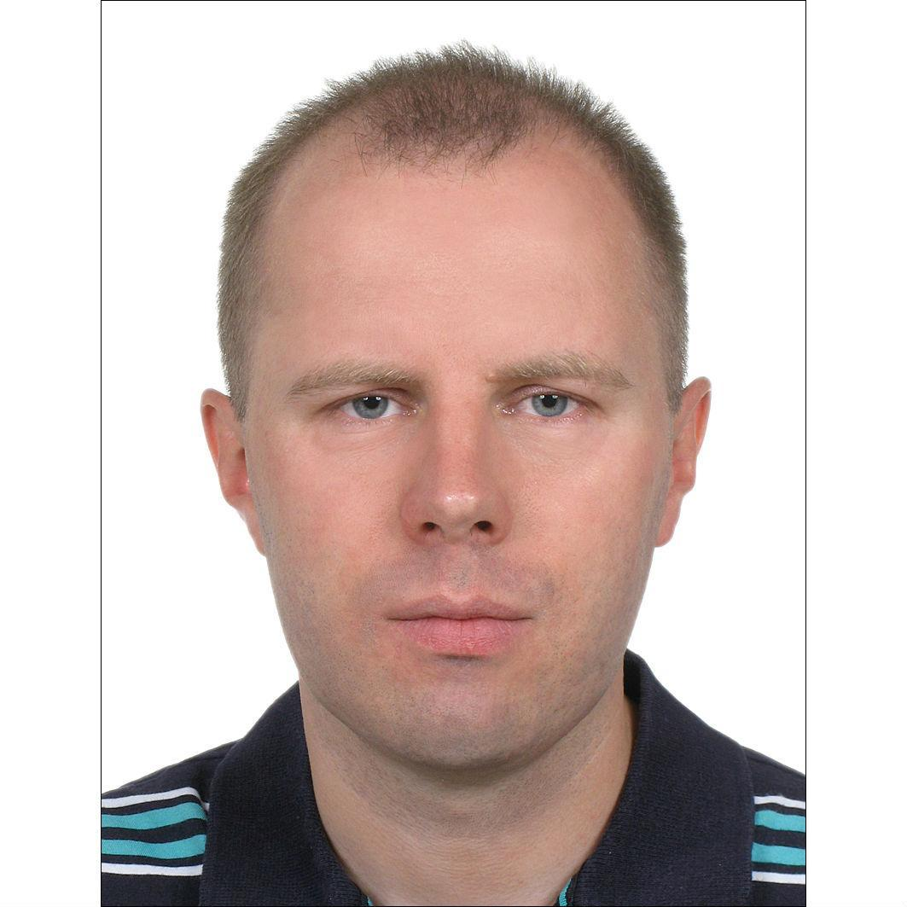

**Phone: +447476145541 E-mail:** [**yuriy@tumakha.uk**](mailto:yuriy@tumakha.uk)

**Address: London, UK**

[**https://tumakha.uk**](https://tumakha.uk)

[**https://linkedin.com/in/tumakha**](https://linkedin.com/in/tumakha)

**PERSONAL SUMMARY**

Senior Developer with 20 years of experience in Java development and 6 years in Scala with strong problem-solving skills. A team player who contributes ideas and takes on challenges.

**KEY SKILLS AND COMPETENCIES**

* Java Back-End: Java, Spring Boot/Data/MVC/Cloud, JPA, Akka Streams, Kafka, Gradle, Maven
* Scala Back-End: Scala, Akka (Cluster, Streams, Http), Apache Spark, Play Framework, Slick, SBT
* Databases: MySQL, Oracle, MongoDB, Cassandra
* Testing: JUnit, DbUnit, JsonUnit, XMLUnit, Mockito, TestNG, REST Assured, Selenium

**WORK EXPERIENCE**

**Scala Developer - HMRC**September 2021 - now, London, UK  
Valuation Office Agency services optimization.  
Scala, Cats, Play Framework, Akka, MongoDB

**Senior Java/Scala Developer - iPlato Healthcare**September 2020 - September 2021, London, UK  
<https://mygp.com> back-end microservices

AWS, Microservices, Docker, Scala, Java 11, Akka, Akka Http, elastic4s, DynamoDB, Debezium, Spring Boot/Cloud, Consul, Elasticsearch, Kafka, RabbitMQ, MySQL

**Senior Software Engineer - Asset Control**August 2019 - February 2020, London, UK  
Scala, Java, AWS, Kubernetes, Docker, Hazelcast, Apache Spark, Akka, Play, Kafka, Cassandra

**Senior Java Software Engineer - Tantalum Corporation**April 2018 - June 2019, London, UK

Telematics Platform development.

Java 8, Microservices, AWS, Spring Boot, Spring Cloud, Consul, Marathon, Kafka, Cassandra

I created from scratch the following microservices:

**api-subscriptions** - Asynchronous integration with company ATT to synchronize users profiles and subscriptions

**svc-ecosystems-gateway** - Integration with Harman endpoints to get device status/change Wi-Fi settings

**svc-trip-batch** - Converting trip telematics data to CSV format to calculate driving score by Octo Telematics

**api-device-administration** - REST API to get device data, associate with user, enable Wi-Fi, cancel registration

**api-device-status** - REST API to get current comprehensive device status and status changes history

**api-admin-router** - Entry point for all REST APIs used by Support Portal

**cmd-sender** - Application to send in free form messages and push notifications to users

**sls-monitoring** - Microservices monitoring Lambda deployed by Serverless framework <https://serverless.com>

**Scala Developer (Contract) - EileanTech Ltd**July 2017 - Mar 2018

Implemented Archipelago framework integration components for Database, JMS, HTTP, JSON, XML and sort/aggregate/transform components.

Scala, Akka, Slick, scalatest, SBT, Git, JMS, JSON, XML

**Software Engineer - 10x Banking**

February 2017 - June 2017, London, UK

Java 8, Maven, AWS, Amazon SQS, DynamoDB, Activiti workflow

**Senior Java Developer - Freelance**

February 2014 - January 2017

Java 8, Camel, Spring, JPA, Spring MVC, Scala, Akka, SBT, Play framework, JIRA plugin

Dashboard to monitor and control Wind Turbines. (Java 8, Spring Boot, SOAP, AngularJS)

Yellowfin BI plugins views for REST APIs (Java 8, yellowfinbi-7.2, retrofit-2, okhttp-3, gson)

**Senior Java Developer - Epam Systems**

September 2013 - January 2014, Kyiv, Ukraine

IBM Java 5, Maven, Spring, Hibernate, JMS, XML, XSLT, JUnit, TDD, Agile

Implemented new features for bank trades processing. Improved testing coverage.

**Senior Java Developer - Ciklum**

January 2012 - May 2013, Kyiv, Ukraine

Java 7, Oracle, Hibernate, Spring, JPA, REST, ActiveMQ, Tapestry, TDD, Agile

Implemented from scratch Players Campaign management solution.

**Senior Java Developer - Thomson Reuters**

December 2007 - January 2012, Kyiv, Ukraine

Java 6-7, Hibernate, JPA, Spring, Web Services, Maven, JUnit, TDD, Agile

Implemented new features for Thomson Reuters commercial portals and internal services.

<https://commerce.reuters.com/agencyaccess/>

**Senior Java Developer - Softline**

December 2006 - December 2007, Kyiv, Ukraine

Java 6, J2EE, MULE ESB, Web Services, JUnit, Cactus, Ant

Developed web-application for managing profiles, import/export XML by HTTPS, FTP.

<http://helpdesk.quantmarketing.com>

**Java Developer - Luxoft**

February 2006 - December 2006, Kyiv, Ukraine

Java 5, J2EE, Servlets, JSP, Struts, Oracle PL/SQL, Oracle CM SDK

Developed web-application for internal use on ChNPP. It is intended for work with electronic archive of documents, integration with the monitoring system of object "Shelter".

**PHP Developer - MitriDAT**

March 2005 - December 2005, Kyiv, Ukraine

PHP, DHTML, MySQL, XML, XSL

SMS Portal for bulk message sending, postponed sending, websites integration.

<http://smsportal.media24.no/>

**EDUCATION**

1997 - 2002: Ternopil Ivan Puluj National Technical University, Ukraine

Lightbend Akka Cluster - Sharding (Scala) (July 2020)

<https://academy.lightbend.com/certificates/5cfa930df02e40f2a79c75308c5beb35>

<https://www.youracclaim.com/users/yuriy-tumakha>

Big Data Analysis with Scala and Spark (April 2017, License KSUENLP7B886)

<https://www.coursera.org/account/accomplishments/verify/KSUENLP7B886>